Electronics Documentation

1. Electronics Block Diagram
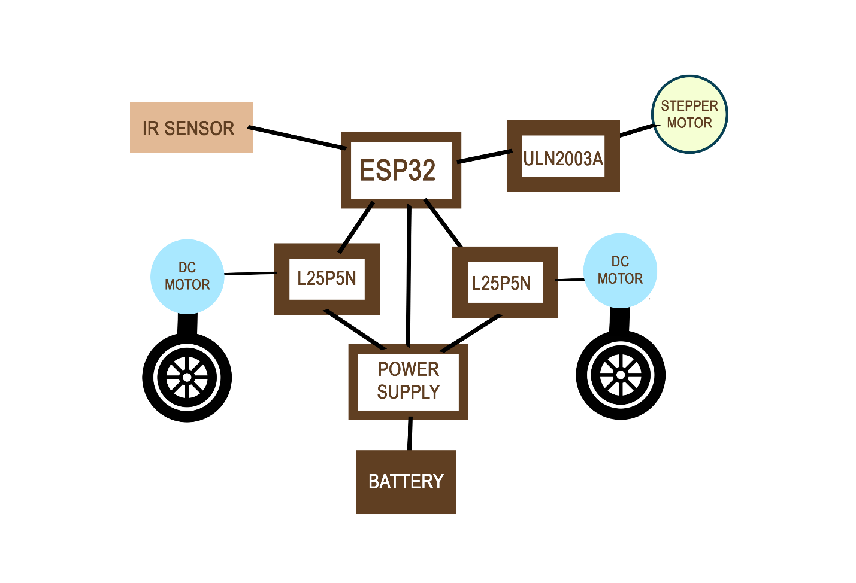

2. Components Table
Component | Quantity | Purpose | Justification
Stepper Motor | 1 | To rotate the top of the doll in a smooth manner | Precise angle is required for this application and hence stepper motor
DC Motor | 2 | To spin the wheels of the cars | DC Motor has been used to be able to spin the wheels fast
IR sensor | 1 | To detect the edge of the stage | IR sensor will be placed near the front of the gown. On detecting no floor. It will stop and move back when it stops detecting a surface.

